Nirakar Shrestha

Professor Wise

CS 320

**Assignment 10**

**Consider the following network. With the indicated link costs, use Dijkstra’s shortest-path algorithm to compute the shortest path from x to all network nodes. Show how the algorithm works by computing a table similar to the one above.**

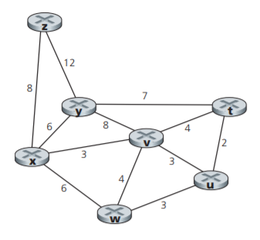

|  |  |  |  |  |  |  |  |
| --- | --- | --- | --- | --- | --- | --- | --- |
| Iteration | N۱ | D(t), p(t) | D(u), p(u) | D(v), p(v) | D(w), p(w) | D(y), p(y) | D(z), p(z) |
| 0 | {x} | ∞ | ∞ | 3, x | 6, x | 6, x | 8, x |
| 1 | {x,v} | 7, v | 6, v | 3, x | 6, x | 6, x | 8, x |
| 2 | {x,v,u} | 7, v | 6, v | 3, x | 6, x | 6, x | 8, x |
| 3 | {x,v,u,w} | 7, v | 6, v | 3, x | 6, x | 6, x | 8, x |
| 4 | {x,v,u,w,y} | 7, v | 6, v | 3, x | 6, x | 6, x | 8, x |
| 5 | {x,v,u,w,y,t} | 7, v | 6, v | 3, x | 6, x | 6, x | 8, x |
| 6 | {x,v,u,w,y,t,z} | 7, v | 6, v | 3, x | 6, x | 6, x | 8, x |